ANSIBLE TASK 01

1.WATCH ANSIBLE-01 VIDEO AND WRITE DOWN NOTES.

2.SETUP ONE MASTER AND TWO WORKER NODES IN ANSIBLE.
#Launch three instances one for master and two for workers and install the ansible in master
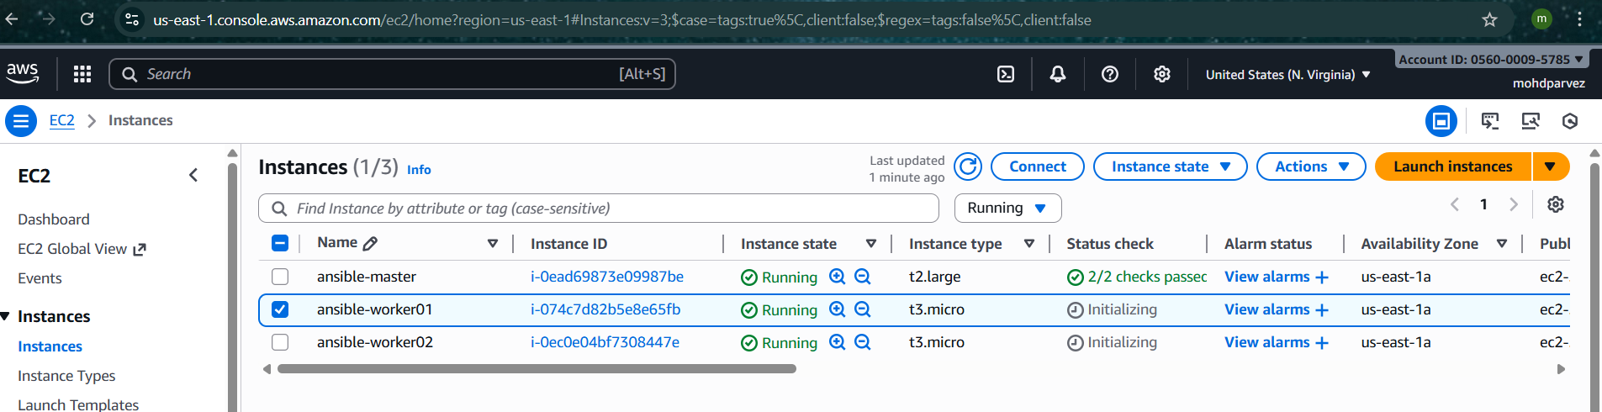
# ansible is python based so check whether python is available or not
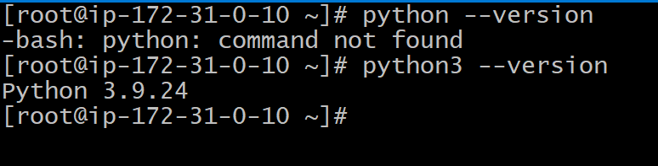
#yum install ansible -y
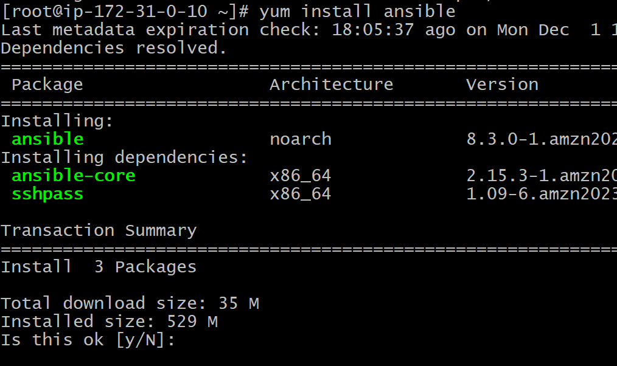
#Now go to the hosts file to add the workers in the master /etc/ansible/
Create file #vi hosts -->
[all]
Privateip:ansibleworker01
Privateip:ansibleworker02
[worker01]
Private_ip
[worker02]
Private_ip
Save it

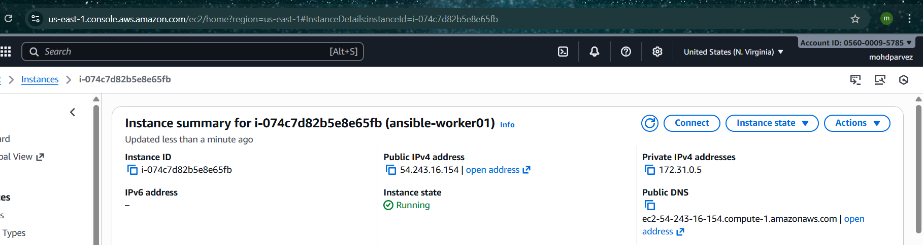
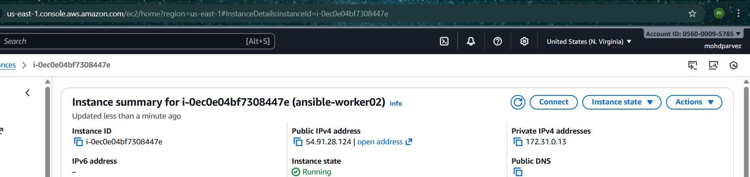

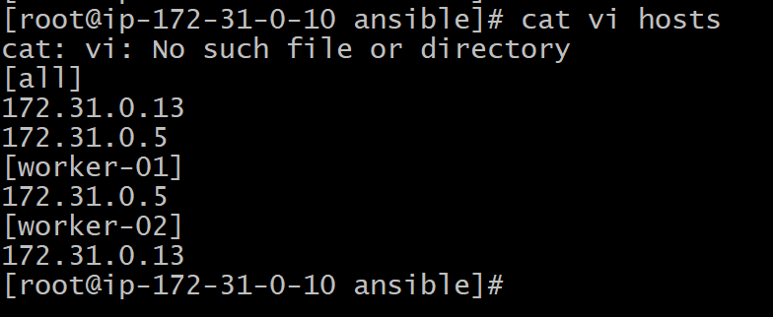
# now create password less authentication for master to workers server
#ssh-keygen
#copy public key to the workers cd /.ssh/autorisedkeys
Paste and save
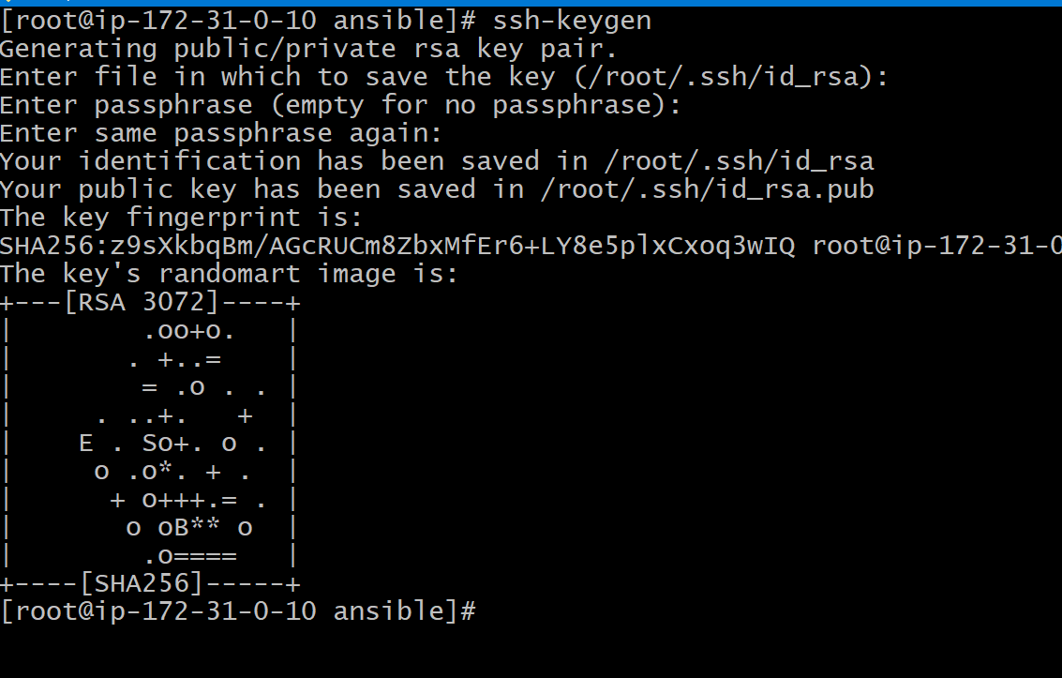
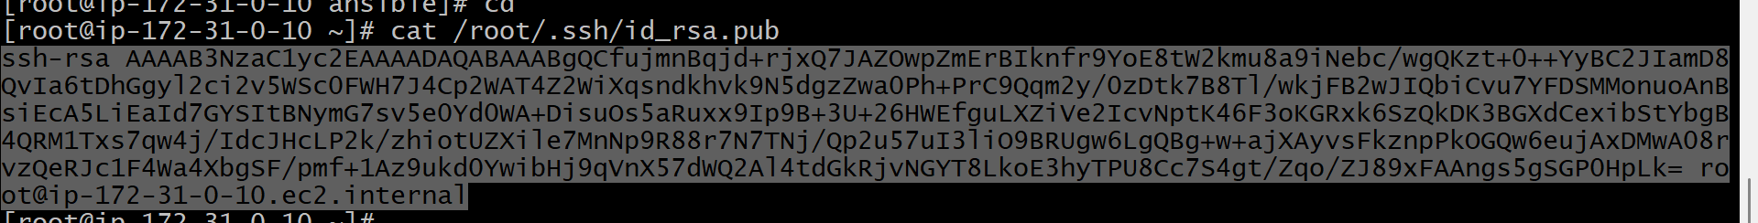
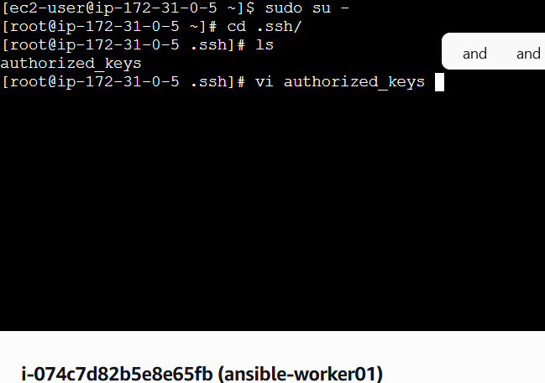
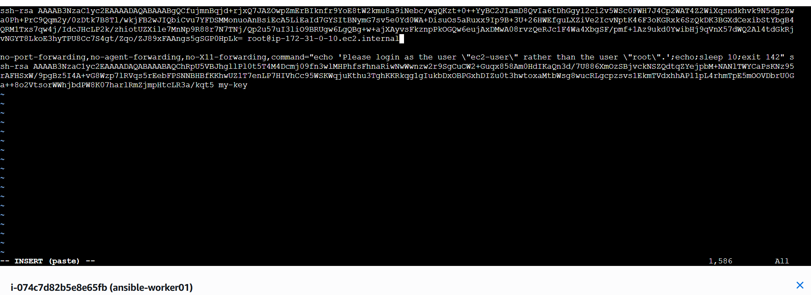
#now in worker02
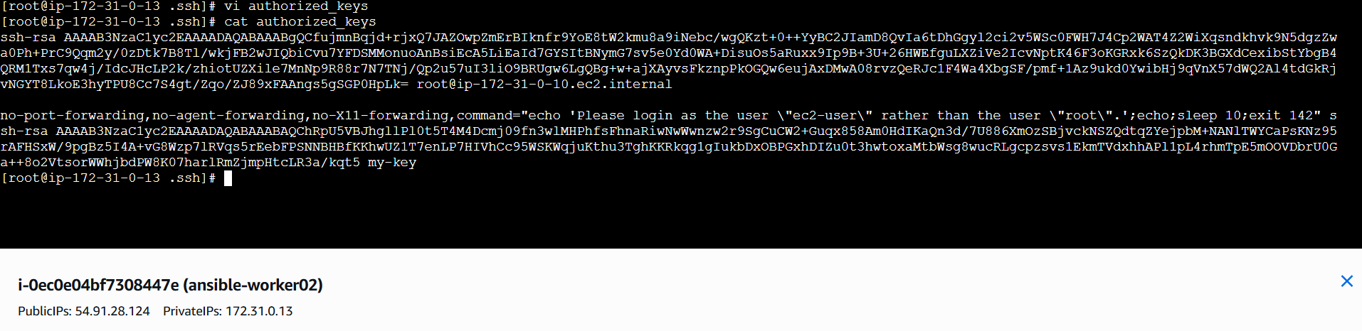

#check the connection between the master and worker
--> ansible all -m ping

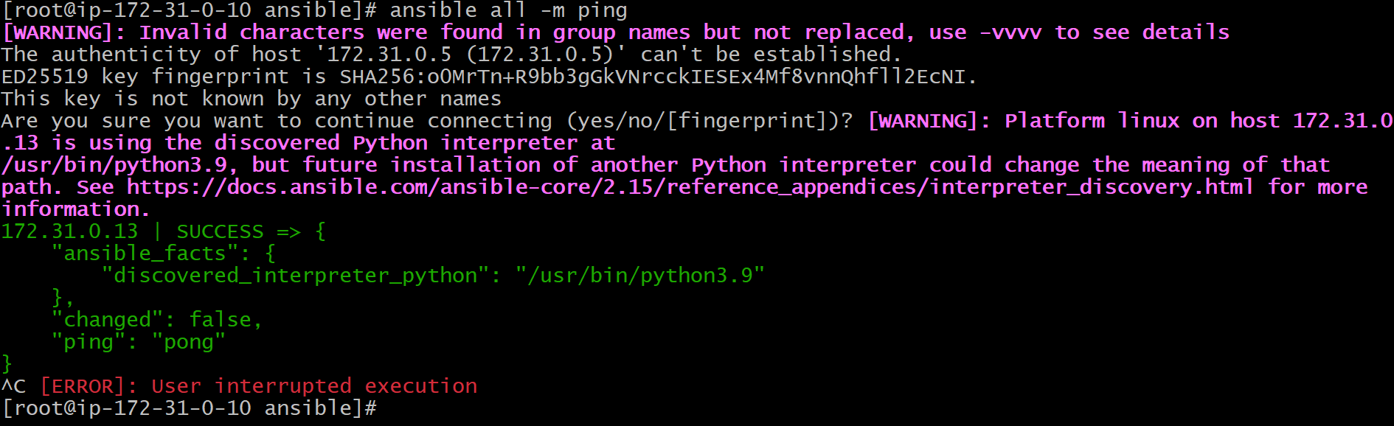

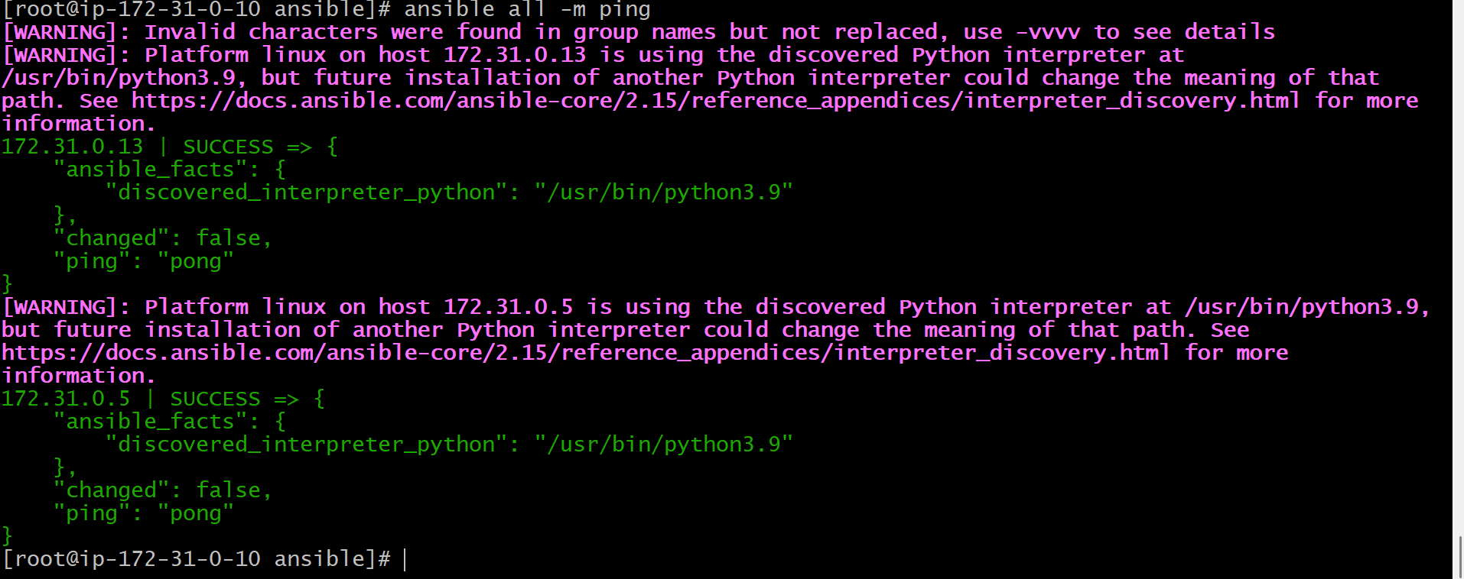
You can see the connection for both the workers are established .

3.EXECUTE THE ADHOC COMMAND SHARED IN

Basic shell command
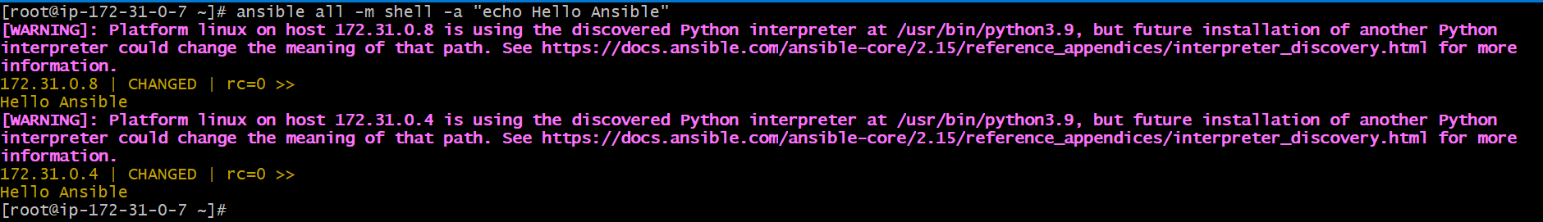
ansible all -m shell -a "echo Hello Ansible"

Check hostname
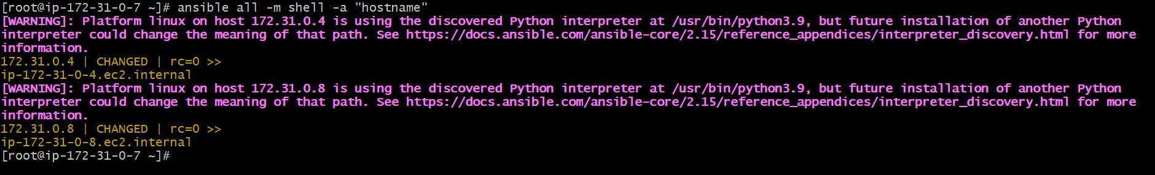
ansible all -m shell -a "hostname"

Uptime of servers
ansible all -m shell -a "uptime"
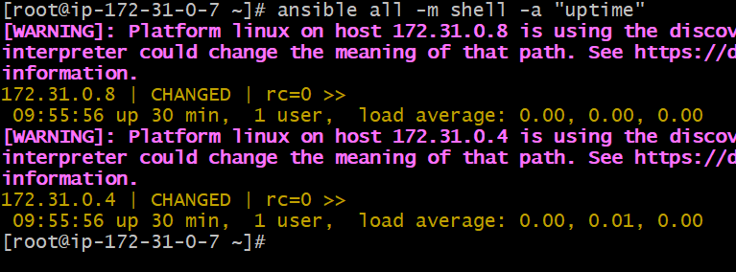

Disk usage with pipe
ansible all -m shell -a "df -h | grep -v tmpfs"
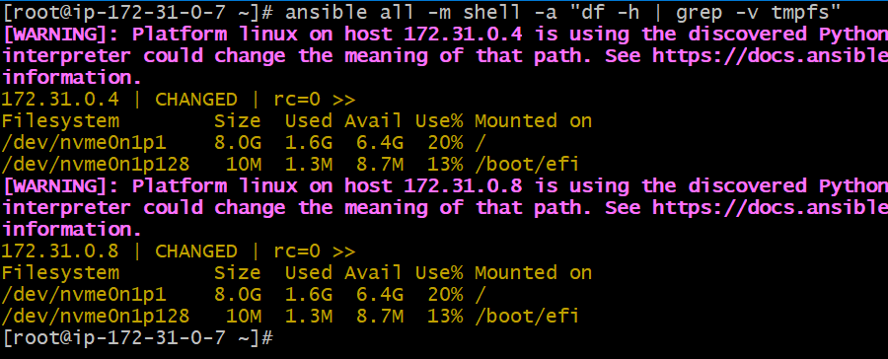

Pipes (|) work only with shell module. Memory usage
ansible all -m shell -a "free -m | awk 'NR==2{print $3,$4}'"
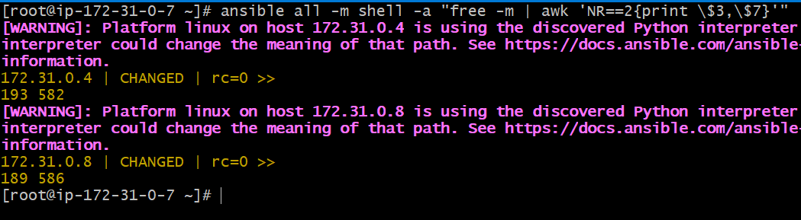
Create a file using shell
ansible all -m shell -a "touch shell_test.txt"
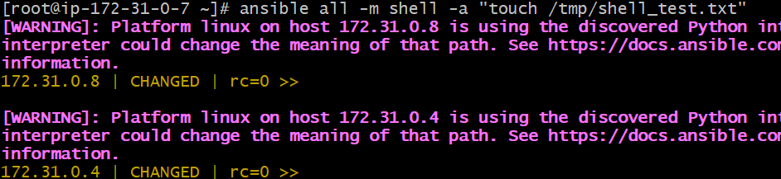

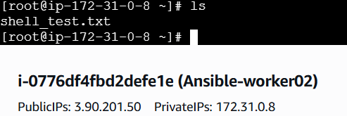

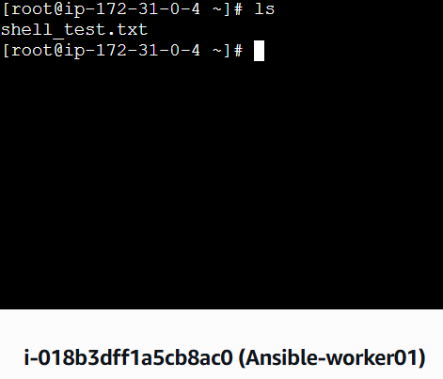
Write text into a file
ansible all -m shell -a "echo 'Practicing Ansible Shell' >> shell_test.txt"
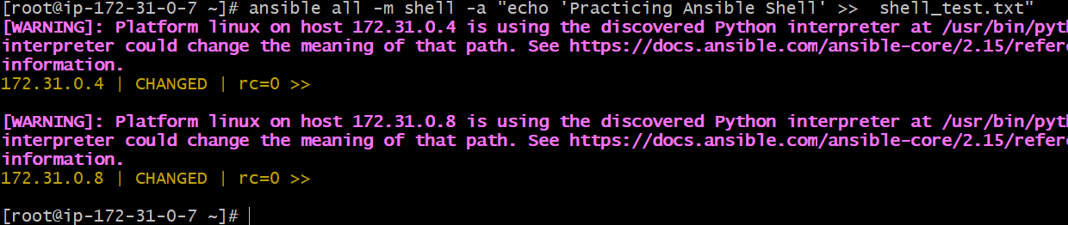
Read file content
ansible all -m shell -a "cat shell_test.txt"
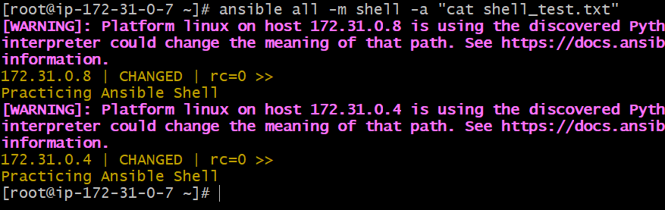
Create directory
ansible all -m shell -a "mkdir -p /opt/shell_dir"
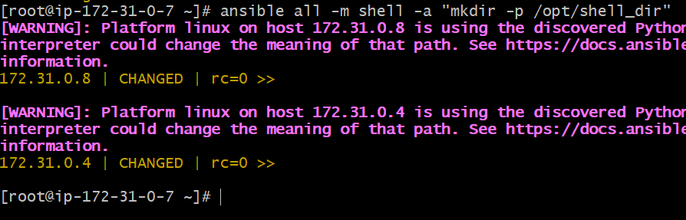

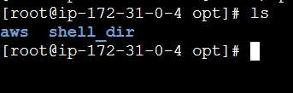

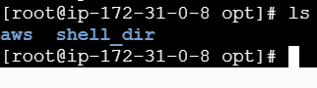

Check running processes
ansible all -m shell -a "ps -ef | head"
